Head of Abstract (Style: Conf_head)
A.A. Author¹, A.A. Author², A.A. Author³ (Style: Conf_authors)
¹ Zavoisky Physical-Technical Institute, FRC Kazan Scientific Center of RAS, Kazan, Russia
²Laboratory (Style: Conf_lab)
³Laboratory (Style: Conf_lab)
The file name should contain the name of the conference, the type of report and the last name of the speaker, separated by a dash, for example, SPСT-poster-Ivanov, MDMR-oral-Petrov. The abstract preparing should be made using this template, for each paragraph, use the appropriate template paragraph styles [1, 2]. (Style: Conf_body first)
Abstracts should be written in English, the size of the abstract is one or two pages including the illustrations and tables. All words in the head of abstract, except conjunctions, articles and prepositions, should be written in capital letters. The name of the speaker should be underlined. The affiliation should contain the title of the organization, city and country. The text body should be typed using the Style: Conf_body text. Figures are preferred as WMF or EPS files. (Style: Conf_body text)
Please, use italics for variables, bold roman type for vectors, insert characters from the menu for writing Greek letters and mathematical symbols in text, and use the MathType equation editor for mathematical equations. (Style: Conf_body text)

1. Schafer A., Horn H., Ahlrichs R.: J. Chem. Phys. 97, 2571–2577 (1992) (Style: Conf_references)
2. Polonskij N.B.: Konstruirovanie elektromagnitnyh ekranov dlya radioelektronnoj apparatury. M.: Sovetskoe radio (1979), 216 p. (In Russian) (Style: Conf_references)

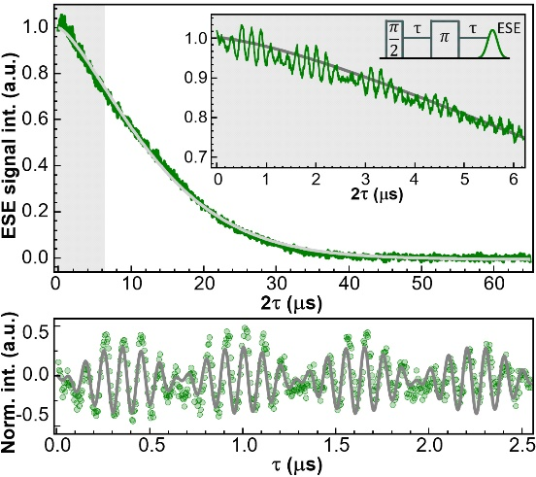

Fig. 1. Fig legend fig legend fig legend fig legend fig legend fig legend fig legend fig legend fig legend fig legend fig legend fig legend fig legend fig legend fig legend fig legend. (Style: Conf_fig legend)

